Subject: English 1  Lesson plan: 1  Date of teaching: 07/10/2015 | Time allowed: 7 periods | Total period taught: 0

UNIT 1: Nice to meet you!

I. OBJECTIVES
By the end of the lesson, the students will be able to:
- Listen to greetings and introductions
- Introduce themselves and others
- Read an article about Leonardo DiCaprio
- Write an email about themselves
- Extend vocabulary about greetings
- Practise using the present tense of be
- Practise the sentence stress

II. METHOD
- Integrated, communicative oriented teaching approach.

III. TECHNIQUES
- Individual work
- Pair work.
- Group work.

IV. TEACHING AIDS
- Textbook.
- Black board, chalk.
- Pictures for teaching vocabulary.
- Cassette player, amplifier, microphone.

V. PROCEDURE
- Greetings.
- Checking students’ attendance: 5 minutes
- Warm-up: Ice-breaker (10 minutes)
- New lesson.

 | Teacher | Students
20’ | Conversation 1: the goal of this section is to present and practice the target vocabulary and grammar of the unit in a typical conversation  - Activity 1: Picture description  - Focuses Ss’ attention on the picture and asks some questions:  Who are the people?  Where are they?  Are the friends or strangers? …  - Elicits questions people usually ask when they first meet someone.  - Activity 2: Listen and practise (CD1- track 4)  - Focuses Ss’ attention on the model conversation  - Plays the recording  - Asks two Ss to model the conversation  - Has Ss practice in pairs  - Activity 3: Pair work  - Shows the examples and has Ss do the activity in pairs  - Asks some pairs to demonstrate their work | - Listen to the T and answer the questions  - Respond to the T  - Listen to the T  - Listen to the recording  - Do the activity  - Practise the conversation  - Present their conversation
20’ | Pronunciation: the goal of this section is to focus on sentence stress  - Models the examples and have Ss repeat  - Plays the recording and has Ss repeat  - Has Ss practise saying the sentences | - Listen and repeat  - Listen and repeat  - Practise the sentences
30’ | Language practice 1: The goal of this section is to present and practise the present tense of “be”  - Activity 1: Explains the rules  - Gives some examples and elicits the meanings of personal pronouns and the structures of “S + be”  - Explains the contractions forms  - Explains the possessive adjectives  - Activity 2: Complete the sentences  - Focuses Ss’ attention on the pictures and gives instructions  - Has Ss do the activity  - Elicits answers and corrects (explains vocabulary if necessary)  - Activity 3: Pair work  - Has Ss work in pairs and talks about themselves  - Invites some Ss to introduce their partners | - Listen to the T  - Listen to the T  - Do the activity  - Correct the exercise  Expected answers:  - My, his, are, is  - I’m, her, are, we’re  - Name’s, am, aren’t, their  - Practise in pairs  - Talk about their partners
20’ | Conversation 2: the goal of this section is to present and practice introduce yourself and others  - Activity 1: Picture description  - Focuses Ss’ attention on the pictures and asks them some questions  Who are in the picture?  Where are they?  Do they know each other?  - Activity 2: Listen and fill in the blanks (CD1 – track 7)  - Gives instructions  - Lets Ss do the activity by themselves  - Plays the recording and checks the answers  - Asks Ss to model the conversation  - Has Ss practise in pairs  - Activity 3: Pair work  - Elicits how the expressions could go into each blank  - Has Ss do the activity in pairs  - Invites some pairs to present their work in front of the class  - Activity 4: Pair work  - Models the conversation  - Has Ss change pairs and practise the conversation | - Respond to the T  - Listen to the T  - Do the activity  - Listen and check the answer  Expected answer: 1b – 2c – 3a  - Model the conversation  - Practise the conversation in pairs  - Respond to the T  - Do the activity  - Present the conversation  - Listen to the T  - Practise the conversation
40’ | Language practice 2: The goal of this section is to present and practise the target grammar – questions with be  - Activity 1: Explains the rules  - Gives some examples and focuses Ss’ attention on the position of be in questions forms  - Focuses Ss’ attention on the wh-words and explains meaning  2. Activity 2: Matching  - Gives instructions and an example  - Has Ss do the activity  - Checks the answers  - Activity 3: Gap-filling  - Gives instructions and an example  - Has Ss do the activity  - Checks the answers  - Activity 4: Pair work  - Gives instructions and an example  - Has Ss do the activity  - Checks the answers  - Activity 5: Workbook  - Has Ss do the workbook (P.2-3-4) | - Listen to the T  - Listen to the T  - Do the activity  - Check answers  Expected answers:  1e – 2f – 3a – 4d – 5c – 6b  - Listen to the T  - Do the activity  - Check answers  Expected answers:  - And you?, Who’s that, That’s  - What’s your name?, Where are you from?, how about you?  - Listen to the T  - Do the activity  - Check answers  - Do the workbook
30’ | Smart Talk:  - Reviews the names of some countries (focus on pronunciation)  - Elicits some useful structures  What’s his real name?  Where are you from?  - Gives instructions and has Ss do the activity in pairs  - Gives feedback | - Listen and respond to the T  - Do the activity  - Listen to the T
30’ | Listening: The goal of this section is to practise listening selectively for key information  - Listen and circle (CD1-track 9)  - Focuses Ss’ attention on the sentences and asks Ss to underline the different information.  - Plays the recording and has Ss do the activity  - Checks the answers  - Listen and circle (CD1-track 10)  - Focuses Ss’ attention on the sentences and elicits possible questions for each answer choice  - Plays the recording and has Ss do the activity  - Checks the answers | - Underline the different information  - Do the activity  - Listen to the T & check the answers  Expected answers:  2a – 3b – 4a – 5b – 6b  - Listen to the T and guess possible questions that come before each answer choice  - Do the activity  - Listen to the T & check the answers  Expected answers:  2a – 3a – 4b – 5a – 6b
40’ | Reading: the goal of this section is to practise reading comprehension  - Activity 1: Background knowledge  - Shows Ss the picture of Leonardo DiCaprio    - Asks Ss some questions:  Who’s that?  Where’s he from?  What does he do?  …  - Elicits related vocabulary  actor (n): using example  role (n): using explanation  - Activity 2: Reading comprehension  - Gives instructions  - Has Ss do the activity  - Checks answer | - Look at the picture and answer the T’s questions  - Respond to the T  - Listen to the T and take note new words.  - Listen to the T  - Do the activity  - Check answers  Expected answers:  - He’s an actor  - He’s from Hollywood, California  - His birthday is November 11  - He is 41 years old  - His mother is form Germany  - His favorite movie is The Godfather
25’ | Enjoying English: The goal of this section is to practice the language in the unit in an enjoyable, meaningful, and personalized way  - Activity 1:  - Gives instructions and elicits some other words as examples  - Has Ss do the activity  - Activity 2:  - Focuses Ss’ attention on the useful language and models the example conversation  What does … mean?  How do you spell…?  Really? That’s my favorite word, too!  - Lets Ss go around, asking and answering about their favorite words | - Give examples  - Do the activity  - Listen to the T  - Do the activity
40’ | Writing: The goal of this section is to practise writing a short email about oneself  - Has Ss read the email and asks Ss to underline the information relating to Judy.  - Gives an example by replacing one’s personal information  - Has Ss do the activity  - Asks some students write their work on the board and gives feedbacks | - Read the email and underline the information relating to Judy  - Listen to the teacher  - Do the activity  - Show the work and correct

VIII. SUMMARY OF UNIT 1: 5 minutes
- T reminds Ss about:
+ Present Tense of be
+ Possessive adjective
+ Useful language of greetings and introductions

IX. HOMEWORK:
- Ss have to do the workbook and prepare for the new lesson.

X. SELF-ASSESSMENT:
- The teaching methods are good because:
+ There are facilities and materials for students to study better.
+ The teacher’s preparation is careful.

Ngày tháng năm 201
THÔNG QUA TỔ BỘ MÔN Chữ ký giáo viên

NGUYỄN THỊ MINH QUÝ Trần Thanh Trúc

Subject: English 1  Lesson plan: 2  Date of teaching: 14/10/2015 | Time allowed: 7 periods | Total period taught: 7

UNIT 2: What do you do?

I. OBJECTIVES
By the end of the lesson, the students will be able to:
- Listen to people talking about jobs and where they live
- Share personal information
- Read an interview with a zookeeper and a window washer
- Write about your job and other personal information
- Extend vocabulary about jobs
- Learn common Wh- questions
- Practise the reduction of do you

II. METHOD
- Integrated, communicative oriented teaching approach.

III. TECHNIQUES
- Individual work
- Pair work.
- Group work.

IV. TEACHING AIDS
- Textbook.
- Black board, chalk.
- Pictures for teaching reading comprehension.
- Cassette player, amplifier, microphone.
- Hand-outs to review the old lesson

V. PROCEDURE
- Greetings.
- Checking students’ attendance: 5 minutes
- Revision of the old lesson: 10 minutes
Present tense of be: Ss work on their own to complete the exercise
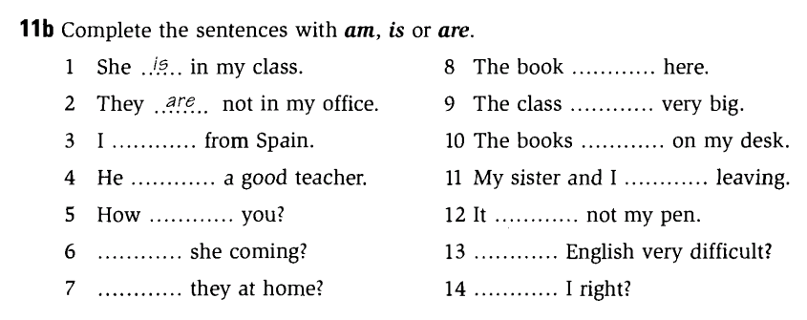
- New lesson.

 | Teacher | Students
20’ | Vocabulary: the goal of this section is to present and practice the target vocabulary of the unit  - Activity 1: Picture labeling  - Lets Ss play the miming game to elicit job titles that Ss may know in English  - Explains the vocabulary items that Ss don’t know and has them do the activity.  - Activity 2: Pair work  - Models the conversation  - Draws Ss’ attention on the use of a/an and how to show agreement and disagreement.  - Has Ss work in pair and do the activity  - Has pairs present their conversations  - Activity 3: Listen and check (CD1-track 12)  - Plays the recording and checks the answers of activity 1 | - Play the games  - Do the activity  - Listen to the T  - Do the activity  - Present the conversations to the class  - Listen and check the answers  Expected answer  1f – 2c – 3a – 4h – 5j  6b – 7d – 8g – 9i – 10e
20’ | Conversation: the goal of this section is to present and practice the target vocabulary and grammar of the unit in a typical conversation  - Activity 1: Picture description  - Focuses Ss’ attention on the picture and asks some questions:  Who are the people?  Where are they?  Are the friends or strangers? …  - Elicits questions people usually ask when they first meet someone.  - Activity 2: Listen and check (CD1-track 12)  - Focuses Ss’ attention on the model conversation  - Pre-teaches the words and phrases  Small world!: using context  Hey!: using context  - Has Ss do the activity  - Plays the recording and checks the answers  - Asks two Ss to model the conversation  - Has Ss practice in pairs  - Activity 3: Pair work  - Shows the examples and has Ss do the activity  - Activity 4: Free practice  - Elicits other examples of job titles and places  - Has Ss practise in pairs | - Listen to the T and answer the questions  - Respond to the T  - Listen to the T  - Do the activity  - Check the answers  Expected answers  1c – 2a – 3b  - Practise the conversation  - Do the activity  - Respond to the T  - Respond to the T  - Do the activity
70’ | Language Practice: the goal of this section is to present and practice common wh-question  - Explain the rules  - Asks Ss to observe the examples in the book  - Elicits the meaning of the examples  - Elicits the use of do/ does  - Has Ss give examples to check understandings  - Activity 1: Matching  - Gives instructions and an example  - Has Ss do the activity  - Checks the answers  - Activity 2: Completing conversations  - Gives instructions and an example  - Has Ss do the activity  - Checks the answers  - Activity 3: Pair work  - Models the example and give instructions  - Has Ss complete the column You  - Has Ss work in pairs to complete the column Your partner  - Checks the Ss’ work and give feedback  - Workbook  - Has Ss do the workbook P.7-8-9  - Checks the answers | - Respond to the T  Expected answers:  Do: goes with plural subject  Does: goes with singular subject  - Listen to the T  - Do the activity  - Check answers  Expected answers:  2c – 3a – 4e – 5b – 6d  - Listen to the T  - Do the activity  - Check answers  Expected answers:  - live  - does, live, lives  - do work, work  - do, do, I’m  - do, do, They’re  - does, work, works  - Listen to the T  - Do the activity  - Listen to the T  - Do the workbook  - Check the answers
15’ | Pronunciation: the goal of this section to focus on the reduced form of “do you”  - Activity 1:Listen and repeat (CD1- track 15)  - Models the examples and has the Ss repeat  - Plays the recording and has Ss practice saying the examples  - Activity 2: Pair work  - Has Ss work in pairs and do the activity | - Listen to the T and repeat  - Listen and practise saying the examples  - Work in pairs and do the activity
40’ | Listening: The goal of this section is to practise listening selectively for key information  - Picture describing  - Focuses Ss’ attention on the pictures and elicits relating vocabulary:  job interview (n): using picture  applicant – application (n): using picture  talkshow (n): using picture  host (n): using picture  - Has Ss guess the content of their conversations  - Listen and number (CD1-track 16)  - Gives instruction and focuses Ss’ attention on the key words  - Plays the recording and has Ss do the activity  - Checks the answers  - Listen and number (CD1-track 17)  - Gives instruction, focuses Ss’ attention on the chart, and elicits possible answers  - Plays the recording and has Ss do the activity  - Checks the answers | - Try to describe the pictures  - Guess the content of the conversations  - Listen to the T  - Do the activity  - Listen to the T & check the answers  Expected answers:  A3 – B2 – C1  - Listen to the T  - Do the activity  - Listen to the T & check the answers  Expected answers:  Jane: model, Boston, New York  Joe: actor, Hollywood, Miami  Alice: Student, Toronto, Vancouver
30’ | Smart Talk:  - Reviews vocabulary (focus on pronunciation)  hospital (n): using explanation  college (n) : using explanation  airport (n) : using explanation  convenience store (n) : using explanation  restaurant (n) : using explanation  office (n) : using explanation  - Gives instructions and has Ss do the activity in pairs  - Gives feedback | - Listen and respond to the T  - Do the activity  - Listen to the T
40’ | Reading: the goal of this section is to practise reading comprehension  - Activity 1: Pre-reading  - Asks Ss to determine the form of the text  - Focuses Ss’ attention on the title and pictures of Chuck and Helen.    - Asks Ss some questions:  What does Chuck do?  Where does he work?  What does Helen Reed do?  Where does she work?  …  - Elicits related vocabulary  dangerous (adj): using antonym  office building (n): using picture  climb (n): using mime  - Activity 2: Reading comprehension (CD1- track 18)  - Gives instructions  - Lets Ss listen to the recording  - Has Ss do the activity  - Checks answer  - Asks Ss some questions:  What does Chuck think about the animals?  Does he like his job?  How long does Helen work a day? A week? | - Respond to the T  Expected answer: an article  - Guess the topic of the article  Expected answer: job  - Respond to the T  Expected answer:  Chuck is a zookeeper.  He works in New York City  Helen Redd is a window washer.  She works in London.  - Listen to the T and take note new words.  - Listen to the T  - Listen to the recording  - Do the activity  - Check answers  Expected answers:  - F – 2. T – 3. F – 4. T – 5. F – 6. F  - Respond to the T  Expected answer:  The animals are beautiful.  He loves his job  Helen works 8 hours a day, 5 days a week
25’ | Enjoying English: The goal of this section is to practice the language in the unit in an enjoyable, meaningful, and personalized way  - Activity 1:  - Elicits some adjectives to describe the jobs  Ex: boring, interesting, hard, easy, dangerous, difficult, helpful…  - Focuses Ss’ attention on the pictures  - Has Ss do the activity 1  - Activity 2:  - Models the example conversation  - Lets Ss go around, asking and answering about what they think of the jobs  - Activity 3:  - Writes the model sentence on the board  - Has Ss report what they learn about other Ss | - Brainstorm adjectives and takes notes  - Identify the jobs in the pictures  - Do the activity  - Do the activity  - Do the activity
30’ | Writing: The goal of this section is to practise writing a paragraph about oneself  - Has Ss fill in the form with their personal information  - Elicits some useful structures  - Has Ss do the activity  - Asks some students write their work on the board and gives feedbacks | - Fill in the form  - Listen to the teacher  - Do the activity  - Show the work and correct

VIII. SUMMARY OF UNIT 2: 5 minutes
- T reminds Ss about:
+ Vocabulary about jobs
+ Common Wh-questions
+ Useful language of sharing personal information

IX. HOMEWORK:
- Ss have to do the workbook and prepare for the new lesson.

X. SELF-ASSESSMENT:
- The teaching methods are good because:
+ There are facilities and materials for students to study better.
+ The teacher’s preparation is careful.
XI. HAND-OUTS:

Ngày tháng năm 201
THÔNG QUA TỔ BỘ MÔN Chữ ký giáo viên

NGUYỄN THỊ MINH QUÝ Trần Thanh Trúc

Subject: English 1  Lesson plan: 3  Date of teaching: 28/10/2015 | Time allowed: 7 periods | Total period taught: 14

UNIT 3: Do you like noodles?

I. OBJECTIVES
By the end of the lesson, the students will be able to:
- Listen to people ordering in a restaurant
- Talk about likes and dislikes
- Read about food in other countries
- Write about your favorite restaurant
- Extend vocabulary about food and drink
- Learn Simple present
- Practise the question intonation

II. METHOD
- Integrated, communicative oriented teaching approach.

III. TECHNIQUES
- Individual work
- Pair work.
- Group work.

IV. TEACHING AIDS
- Textbook.
- Black board, chalk.
- Cassette player, amplifier, microphone.
- Hand-outs for mini communication game

V. PROCEDURE
- Greetings.
- Checking students’ attendance: 5 minutes
- Revision of the old lesson: 10 minutes
Common Wh-questions:T lets Ss play a mini communication game
Instructions:
Each S has half of the handout (as the sample below). Every S has to ask and answer the question “What do you do?” to find his/her partner (who shares the same job with him/her). Then together with the partner, S matches two halves of the handout to make a complete questionnaire. Ss who finish answering the questionnaire first will win the game.

What’s your
When’s your
How old
Where do you
Where do you
What’s your favorite
actor
name?
date of birth?
are you?
come from?
live?
movie?
actor

- New lesson.

 | Teacher | Students
20’ | Vocabulary: the goal of this section is to present and practice the target vocabulary of the unit  - Activity 1: Label the pictures  - Explains the vocabulary items that Ss don’t know and has them do the activity.  - Activity 2: Listen and check (CD1-track 19)  - Gives instructions  - Plays the recording and allows time for Ss to correct their answers  - Plays the recording again and focus Ss’ attention on the pronunciation  - Activity 3: Complete the chart  - Explains the 4 categories: meat, seafood, vegetables, others  - Elicits other examples  - Has Ss do the activities | - Do the activity  - Listen to the T  - Do the activity  Expected answer  1i – 2f – 3c – 4o – 5d  6a – 7l – 8h – 9g – 10j  11m – 12k – 13e – 14e – 15n  - Practise saying the words  - Listen to the T  - Respond to the T  - Listen and check the answers  Expected answer  Meat: beef, chicken  Seafood: salmon, shrimp, tuna  Vegetables: lettuce, onions, potatoes, tomatoes  Others: mushrooms, cheese, noodles, rice, soy sauce, soup
20’ | Conversation: the goal of this section is to present and practice the target vocabulary and grammar of the unit in a typical conversation  - Activity 1: Picture description  - Focuses Ss’ attention on the picture and asks some questions:  Who are the people?  Where are they?  What are they going to do?  - Elicits different kinds of restaurants Ss know and the common food they serve.  - Activity 2: Listen and check (CD1-track 20)  - Focuses Ss’ attention on the model conversation  - Pre-teaches the words and phrases  Starving (adj): using synonym  Dumpling (n): using picture  Great idea!: using context  - Has Ss do the activity  - Plays the recording and checks the answers  - Asks two Ss to model the conversation  - Has Ss practice in pairs  - Activity 3: Pair work  - Shows the examples and has Ss do the activity  - Activity 4: Free practice  - Elicits other examples of food and invitation expressions  - Has Ss practise in pairs | - Listen to the T and answer the questions  - Respond to the T  - Listen to the T  - Do the activity  - Check the answers  Expected answers  1c – 2b – 3a  - Practise the conversation  - Do the activity  - Respond to the T  - Do the activity
70’ | Language Practice: the goal of this section is to present and practice Simple present  - Explain the rules  - Asks Ss what food they like or dislike and uses their ideas to make sample sentences in Simple present  - Elicits the use of do/ does and V_{s/es}/ V_{bare}  - Gives the general form  (+) S + V/ V_{s/es} + …  (-) S + don’t/ doesn’t + V_{bare} + …  (?) Do/ Does + S + V_{bare} + …?  - Has Ss give some more examples to check understandings  - Activity 1: Complete the conversations  - Gives instructions and an example  - Has Ss do the activity  - Checks the answers  - Activity 2: Complete the sentences  - Gives instructions and an example  - Has Ss do the activity  - Checks the answers  - Activity 3: Pair work  - Models the example and give instructions  - Has Ss write their own questions  - Has Ss work in pairs, ask and answer questions they have just written  - Checks the Ss’ work and give feedback  - Workbook:  - Has Ss do the workbook P.12-13-14  - Checks the answers | - Respond to the T  Expected answers:  Do - V_{bare}: goes with plural subject  Does – V_{s/es}: goes with singular subject  - Take notes  - Respond to the T  - Listen to the T  - Do the activity  - Check answers  Expected answers:  - Does, like, she does  - Does, like, he doesn’t  - Do, like, they do  - Listen to the T  - Do the activity  - Check answers  Expected answers:  - hates  - doesn’t like, likes  - don’t like, like  - does, like, hates  - does, hate, does, likes  - Listen to the T  - Do the activity  - Listen to the T  - Do the workbook  - Check the answers
15’ | Pronunciation: the goal of this section to focus on the question intonation  - Activity 1:Listen and repeat (CD1- track 22)  - Models the examples and has the Ss repeat  - Plays the recording and has Ss practice saying the examples  - Activity 2: Pair work (CD1- track 22)  - Has Ss work in pairs and do the activity | - Listen to the T and repeat  - Listen and practise saying the examples  - Work in pairs and do the activity
35’ | Listening: The goal of this section is to practise listening selectively for key information  - Picture describing  - Focuses Ss’ attention on the pictures and elicits relating vocabulary  order (v) (n): using explanation  ramen (n): using picture  udon (n): using picture  soba (n): using picture  spaghetti (n): using picture  pizza (n): using example  lasagna (n): using picture  - Has Ss guess what the speakers will say  - Listen and number (CD1-track 23)  - Gives instruction and focuses Ss’ attention on the key words  - Plays the recording and has Ss do the activity  - Checks the answers  - Listen and number (CD1-track 24)  - Gives instruction, focuses Ss’ attention on the pictures  - Plays the recording and has Ss do the activity  - Checks the answers  - Focuses Ss attention on the language used to ask for a menu and order food  Can I have a menu?  Do you have a menu?  Is there a menu?  I’ll have … | - Try to describe the pictures  - Guess what the speakers will say  - Listen to the T  - Do the activity  - Listen to the T & check the answers  Expected answers:  A2 – B1 – C3  - Listen to the T  - Do the activity  - Listen to the T & check the answers  Expected answers:  Soba – spaghetti – salad  - Listen to the T and take notes
30’ | Smart Talk:  - Reviews vocabulary of food (focus on pronunciation)  - Gives instructions and has Ss do the activity in pairs  - Gives feedback | - Listen and respond to the T  - Do the activity  - Listen to the T
40’ | Reading: the goal of this section is to practise reading comprehension  - Activity 1: Pre-reading  - Focuses Ss’ attention on the title and pictures  - Explains the meaning of “eat out”  - Helps Ss identify the places mentioned in the text via pictures  - Lets Ss brainstorm the food they know from those places  - Elicits related vocabulary  chili pepper (n): using drawing  sea weed (n): using drawing  roll (n): using mime  food cart (n): using drawing  cuisine (n): using synonym  doggy bag (n): using context  container (n): using synonym  serve (v): using explanation  describe (v): using translation  recommend (v): using translation  offer (v): using translation  include (n): using synonym  - Activity 2: Reading comprehension (CD1-Track 25)  - Gives instructions and focuses on the reading strategy of guessing meaning from the context  - Has Ss listen to the recording  - Has Ss do the activity  - Checks answer  - Asks Ss some questions:  What is kimchi made from?  When do restaurants serve kimchi?  What are famous street foods in Seoul?  What are the styles of San Francisco food?  What can people find in a Sunday brunch?  What is doggy bag used for?  - Activity 3: Pair work  - Has Ss work in pair talking about what food they want to try and why? | - Respond to the T  - Listen to the T and take note new words.  - Listen to the T  - Listen to the recording  - Do the activity  - Check answers  Expected answers:  - d– 2. c – 3. b – 4. a  - Respond to the T  Expected answer:  Kimchi is made from cabbage, chili peppers, and vegetables  They serve kimchi almost every meal  Kimbap, dukbokki, chicken kebabs and dumplings  Japanese – Italian, Korean – American  Eggs, pancakes, sandwiches, salmon, home fries  To take food people don’t finish  - Work in pairs and do the task
25’ | Enjoying English: The goal of this section is to practice the language in the unit in an enjoyable, meaningful, and personalized way  - Activity 1:  - Elicits some foods and explains the questions in the survey  - Has Ss fill in the first column in the box by themselves  - Activity 2:  - Models the example conversation  - Lets Ss get onto groups, asking and answering the survey  - Asks some Ss to report their group work  - Activity 3:  - Elicits information about China and Mexico, for example, cities and foods  - Models the conversation for the class  - Has Ss do the activity in groups  - Has each group present its conversation | - Brainstorm and takes notes  - Report in front of the class  - Listen to the T  - Do the activity  - Present in front of the class  - Respond to the T  - Listen to the T  - Do the activity  - Present in front of the class
30’ | Writing: The goal of this section is to practise writing a paragraph about oneself  - Has Ss read the letter and answer the question:  Where are they?  What food do they like?  What’s their favorite Japanese food?  - Elicits some useful structures  Do you like…? What about you?  - Has Ss do the activity based on the questions and structures  - Asks some students write their work on the board and gives feedbacks | - Answer the questions  - Listen to the teacher  - Do the activity  - Show the work and correct

VIII. SUMMARY OF UNIT 3: 5 minutes
- T reminds Ss about:
+ Vocabulary about foods
+ Simple present with the verb “like”
+ Useful language to ask and answer about favorite foods and meals

IX. HOMEWORK:
- Ss have to do the workbook and prepare for the new lesson.

X. SELF-ASSESSMENT:
- The teaching methods are good because:
+ There are facilities and materials for students to study better.
+ The teacher’s preparation is careful.
XI. HAND-OUTS:

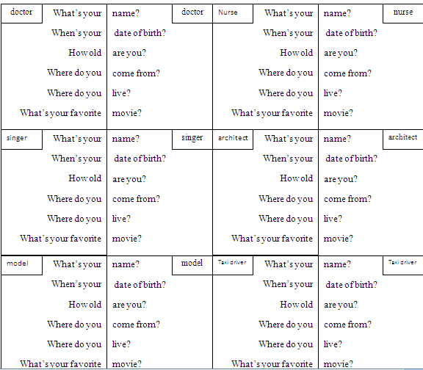
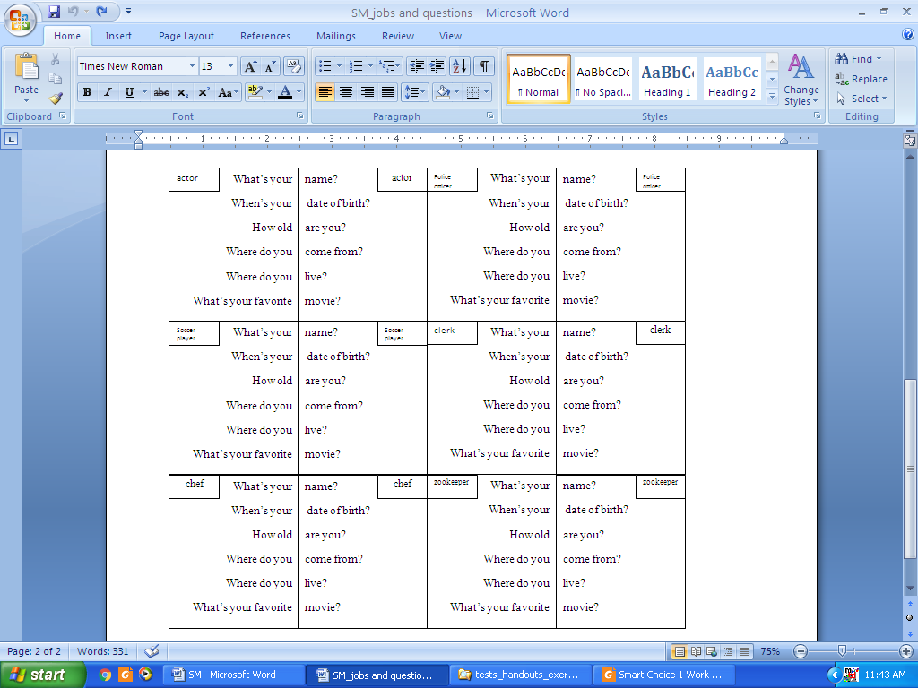

Ngày tháng năm 201
THÔNG QUA TỔ BỘ MÔN Chữ ký giáo viên

NGUYỄN THỊ MINH QUÝ Trần Thanh Trúc

Subject: English 1  Lesson plan: 4  Date of teaching: 11/11/2015 | Time allowed: 2 periods | Total period taught: 21

Review: Unit 1-3

I. OBJECTIVES
This unit aims to review:
- Vocabulary: Units 1-3
- Grammar: The simple present tense
- Listening: Listening comprension skill
- Reading: Reading comprension skill

II. METHOD
- Integrated, communicative oriented teaching approach.

III. TECHNIQUES
- Individual work
- Pair work.
- Group work.

IV. TEACHING AIDS
- Textbook.
- Black board, chalk.
- Cassette player, amplifier, microphone.

V. PROCEDURE
- Greetings.
- Checking students’ attendance: 5 minutes
- Revision of the old lesson: 10 minutes
Food and drink: T lets Ss play the picture-labeling game. Then T has them express what food they like and why they like those ones.
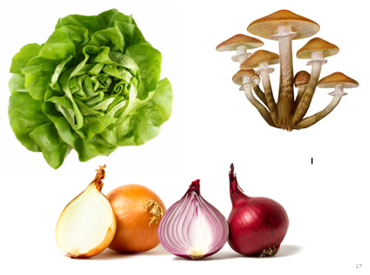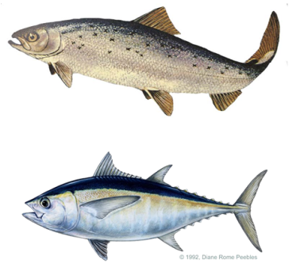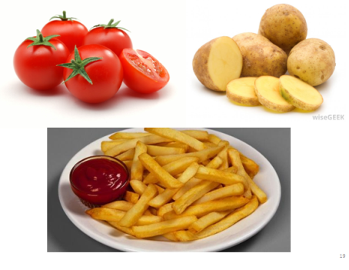
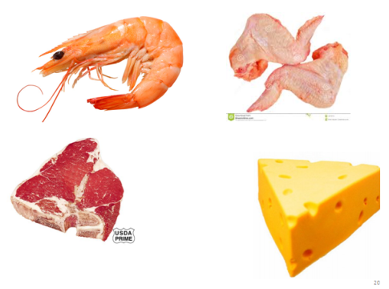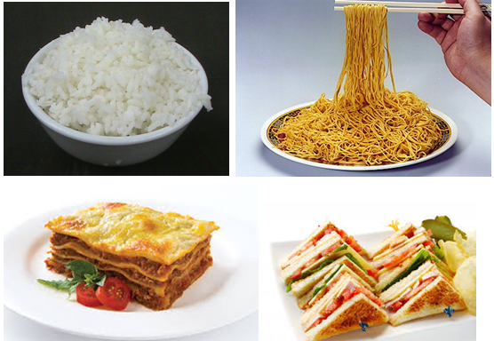

- New lesson.

 | Teacher | Students
10’ | Song: the goal of this section is to review the language presented in Unit 1-3  - Activity 1: Pre-listening  - Focus Ss’ attention on the picture and asks Ss some questions:  Where’s the boy?  Why is he sad?  - Elicits some vocabulary  break up (v): using explanation  ex-girlfriend (n): using explanation  heartbroken (adj): using explanation  - Activity 2: While-listening (CD1 – track 26)  - Plays the recording  - Has Ss to fill in the blanks | - Respond to the T  - Listen to the recording  - Do the activity  Expected answers  - house  - mother  - dog  - letter  - ring  - happy
20’ | Story: the goal of this section is to review and practice the language presented in Unit 1-3 in a fun way  - Activity 1:  - Focuses Ss’ attention on the comic strip and asks some questions:  Where are people?  - Pre-teaches some new words  magnifying glass (n): using picture  ice-cream sundae (n): using picture  - Activity 2: (CD1 – track 27)  - Focuses Ss’ attention on the blanks and the answers choice  - Model the first one as an example  - Has Ss do the activity  - Plays the recording and checks the answers  - Activity 3: Pair work  - Asks two Ss to model the conversation  - Has Ss practice in pairs  - Activity 4: Free practice  - Shows the examples and has Ss do the activity  - Has Ss perform in front of the class  - Activity 5: Workbook  - Has Ss do the workbook P.16-19 | - Listen to the T and answer the questions  - Listen to the T and take notes  - Listen to the T  - Listen to the T  - Do the activity  - Check the answers  Expected answers  1c– 2d – 3b – 4a  - Practise the conversation  - Do the activity  - Do the activity using their ideas  - Perform in front of the class
45’ | One-period Test 1

VIII. SUMMARY: 5 minutes
- T reminds Ss about main content of the lesson

IX. HOMEWORK:
- Ss have to do the workbook and prepare for the new lesson.

X. SELF-ASSESSMENT:
- The teaching methods are good because:
+ There are facilities and materials for students to study better.
+ The teacher’s preparation is careful.

Ngày tháng năm 201
THÔNG QUA TỔ BỘ MÔN Chữ ký giáo viên

NGUYỄN THỊ MINH QUÝ Trần Thanh Trúc
Subject: English 1  Lesson plan: 5  Date of teaching: 11/11/2015 | Time allowed: 7 periods | Total period taught: 23

UNIT 4: How often do you do yoga?

I. OBJECTIVES
By the end of the lesson, the students will be able to:
- Listen to interviews about exercises routines
- Talk about habits and routines
- Read about free places and events
- Write about your typical weekend
- Extend vocabulary about sports and exercise
- Learn Frequency adverbs
- Practise sentence stress

II. METHOD
- Integrated, communicative oriented teaching approach.

III. TECHNIQUES
- Individual work
- Pairwork.
- Group work.

IV. TEACHING AIDS
- Textbook.
- Black board, chalk.
- Pictures for teaching vocabulary.
- Cassette player, amplifier, microphone.

V. PROCEDURE
- Greetings.
- Checking students’ attendance: 5 minutes
- Revision of the old lesson: 10 minutes
Simple present: T has Ss complete the text, using the verbs in the parentheses:

These are Harrito and Yoko. They __________ (be) from Japan. But they __________ (not live) in Japan. They __________ (live) in USA. Harrito __________ (be) a doctor, and he __________ (work) in hospital. Yoko is a teacher. She __________ (teach) math. They __________ (have) a daughter. Her name __________ (be) Sarah. She __________ (be) 7 years old and she __________ (go) to primary school in New York.
- New lesson.

 | Teacher | Students
20’ | Vocabulary: the goal of this section is to present and practice the target vocabulary of the unit  - Activity 1: Survey  - Lets Ss play a miming games to review and elicits new words about sports  - Has Ss complete the survey with their own information  - Activity 2: Pair work  - Models the example conversation  - Lets Ss get onto pairs, asking and answering questions  - Activity 3+4: Complete the chart (CD1 - track 28)  - Gives instructions and some examples with “go”, “do”, “play”  - Sets time and lets Ss do the activity  - Elicits answers  - Plays the recording and allows time for Ss to correct their answers  - Plays the recording again and focus Ss’ attention on the pronunciation | - Play games  - Do the activities  - Listen to the T  - Do the activity  - Listen to the T  - Do the activity  - Respond to the T  Expected answer  Go: swimming, bicycling, bowling, jogging  Do: yoga, martial arts, taichi  Play: soccer, tennis, basketball  - Listen to the recording
20’ | Conversation: the goal of this section is to present and practice the target vocabulary and grammar of the unit in a typical conversation  - Activity 1: Picture description  - Focuses Ss’ attention on the picture and asks some questions:  Who are the people?  Where are they?  What is the women reading?  - Elicits different kinds of restaurants Ss know and the common food they serve.  - Activity 2: Listen and check (CD1-track 29)  - Focuses Ss’ attention on the model conversation  - Pre-teaches the words and phrases  crowded (adj): using explanation  keep fit (v): using example  gym (n): using explanation  - Has Ss do the activity  - Plays the recording and checks the answers  - Asks two Ss to model the conversation  - Has Ss practice in pairs  - Activity 3: Pair work  - Shows the examples and has Ss do the activity  - Activity 4: Free practice  - Elicits other examples of sports  - Has Ss practise in pairs | - Listen to the T and answer the questions  - Respond to the T  - Listen to the T  - Do the activity  - Check the answers  Expected answers  1c – 2a – 3d – 4b  - Practise the conversation  - Do the activity  - Do the activity  - Respond to the T  - Do the activity
70’ | Language Practice: the goal of this section is to present and practice Frequency adverbs  - Explain the rules  - Asks Ss what sports they like or dislike and the frequency they play those sports, then uses their ideas to make sample sentences in Simple present  - Elicits the meaning of question word “how often”, frequency adverbs  - Elicits the position of frequency adverbs and time phrases  - Has Ss give some more examples to check understandings  - Activity 1: Complete the sentences  - Gives instructions and an example  - Has Ss do the activity  - Checks the answers  - Activity 2: Complete the sentences  - Gives instructions and an example  - Has Ss do the activity  - Checks the answers  - Activity 3: Pair work  - Models the example and give instructions  - Has Ss write their own conversations  - Has Ss work in pairs, asking and practicing their conversations  - Checks the Ss’ work and give feedback  - Workbook:  - Has Ss do the workbook P.21-23  - Checks the answers | - Respond to the T  Expected answers:  Frequency adverbs: goes before verbs or after tobe  Time phrases: goes at the beginning or at the end of the sentence  - Respond to the T  - Listen to the T  - Do the activity  - Check answers  Expected answers:  - Usually  - Never  - Twice a week  - Everyday  - sometimes  - Listen to the T  - Do the activity  - Check answers  - Listen to the T  - Do the activity  - Work in pairs  - Listen to the T  - Do the workbook  - Check the answers
15’ | Pronunciation: the goal of this section to focus on the sentence stress  - Activity 1:Listen and repeat (CD1 – track 31)  - Models the examples and has the Ss repeat  - Plays the recording and has Ss practice saying the examples  - Activity 2: Pair work  - Has Ss work in pairs and do the activity | - Listen to the T and repeat  - Listen and practise saying the examples  - Work in pairs and do the activity
35’ | Listening: The goal of this section is to practise listening selectively for key information  - Picture describing  - Focuses Ss’ attention on the pictures and encourages Ss to describe what they see  - Pre-teaches new words (using examples, drawings)  surfing (n): using explanation  beach (n): using example  museum (n): using example  - Has Ss guess what the speakers will do for fun  - Listen and number (CD1-track 32)  - Gives instruction and focuses Ss’ attention on the key words  - Plays the recording and has Ss do the activity  - Checks the answers  - Listen and complete the chart (CD1-track 33)  - Gives instruction, focuses Ss’ attention on 4 kinds of information: name, age, activity, frequency  - Plays the recording and has Ss do the activity  - Checks the answers | - Try to describe the pictures  - Listen to the T and take notes  - Guess what the speakers will do for fun  - Listen to the T  - Do the activity  - Listen to the T & check the answers  Expected answers:  A1 – B3 – C2  - Listen to the T  - Do the activity  - Listen to the T & check the answers  Expected answers:  Greg:: 20, goes swimming, every morning  Alice: 27, visits museums, two days a week  Tom: 39, goes bowling, every Wednesday
30’ | Smart Talk:  - Reviews useful structure  What does he/she do to keep fit?  How often does he/she …?  Does he/she like it?  - Gives instructions and has Ss do the activity in pairs  - Gives feedback | - Listen and respond to the T  - Do the activity  - Listen to the T
40’ | Reading: the goal of this section is to practise reading comprehension  - Activity 1: Warm up and lead in  - Sticks the pictures of places for entertaining on the board and let the Ss guess the words    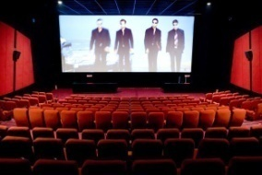      - Activity 2: Pre-reading  - Focuses Ss’ attention on the title and asks them to guess the topic of the article  - Teaches some new words (asks concept- checking questions when necessary)  entertainment (n) – using examples  music show/ music festival (n) – using synonyms  downtown (n) – using translation  wildlife (n) – using picture    totem pole (n) – using picture and translation    ocean (n) – using picture and translation  - Elicits some adjectives to give comments  beautiful  wonderful  great  terrific  amazing  - Asks Ss some question to lead in the article  Who are in the article?  Where are they from?  Where do they live?  Do you know anything about these places?  - Activity 3: Reading comprehension (CD1-track 34)  - Task 2: Read and check  - Gives instructions and dry runs (help Ss scan the text quickly to find key words)  - Has Ss do the activity  - Checks answers: has Ss locate information and explain their choices  - Asks Ss some questions when eliciting answers from Ss (explains vocabulary that Ss can’t understand)  *Brian  How often does Brian go to the beaches?  Does music show cost much?  How often does Brian go to the parks?  *Sarah  When do people usually go to the outdoor market?  What can we do in the mountain?  What is the name of the park? Is it big or small?  - Task 3: Read and answer  - Gives instructions and dry runs (help Ss underline key words in the questions, scan and skim the text )  - Has Ss do the activity  - Checks answers: has Ss locate information and explain their choices  - Asks Ss some follow-up questions when eliciting answers from Ss (explains vocabulary that Ss can’t understand)  Does Brian like the Manly beach?  What happens in October?  How large is Stanley Park?  - Activity 4: Post- reading  - Writes the question on the board?  “Which place do you want to visit? Why?”  - Models the answer and lets Ss work in pairs in about 1 minute  - Invites some Ss to share their answers  - Focuses Ss’ attention on the structure  “It’s a great place to visit.”  - Extends the structure by using new vocabulary  - Lets Ss work talk about the funs things in their hometown using the structure | - Enjoy the game  Expected answers:  beach, restaurant,  movie theater, park,  outdoor market, skiing,  outdoor concert, mountain  - Respond to the T  Expected answer: free leisure activities  - Listen and respond to the T  - Take note new words.  - Listen and respond to the T  - Take note new words.  - Respond to the T  Expected answer:  Brian Burns and Sarah Chan  Australia and Canada  Brian lives in Sydney  …..  - Listen to the T  - Do the activity  - Check answer  Expected answer:  Brian: beaches, music, parks  Sarah: markets, mountains, parks  Usually  No, it’s free  Sometimes  On Saturday afternoon  Ski  Stanley park. It’s big.  - Listen to the T  - Do the activity  - Check answer  Expected answer:  1. a park  2. in January  3. You can ski in the mountain and swim in the Pacific Ocean  4. not very far from downtown  Expected answer:  Yes, that’s his favorite beach  There’s an international jazz festival  It’s 4 square kilometers  - Listen to the T  - Work in pairs  - Share the ideas  - Listen to the T  - Work in pairs
25’ | Enjoying English: The goal of this section is to practice the language in the unit in an enjoyable, meaningful, and personalized way  - Activity 1: Pair work  - Elicits some sports and reminds the structure of How often  - Gives examples and asks Ss to work in pairs to do the activity  - Activity 2:  - Models the example conversation  - Lets Ss get onto groups, asking and answering the survey  - Activity 3:  - Models the report for the class  - Has each group present its conversation | - Brainstorm and take notes  - Do the activity  - Listen to the T  - Do the activity  - Present in front of the class
30’ | Writing: The goal of this section is to practise writing a paragraph about oneself  - Has Ss read the email and answer the question:  What does the writer do on Saturday morning, afternoon, night, and Sunday?  - Has Ss write their own email  - Asks some students write their work on the board and gives feedbacks | - Answer the questions  - Do the activity  - Show the work and correct

VIII. SUMMARY OF UNIT 4: 5 minutes
- T reminds Ss about:
+ Vocabulary about sports and exercise
+ Simple present with frequency adverbs
+ Useful language to ask and answer about habits and routines

IX. HOMEWORK:
- Ss have to do the workbook and prepare for the new lesson.

X. SELF-ASSESSMENT:
- The teaching methods are good because:
+ There are facilities and materials for students to study better.
+ The teacher’s preparation is careful.

Ngày tháng năm 201
THÔNG QUA TỔ BỘ MÔN Chữ ký giáo viên

NGUYỄN THỊ MINH QUÝ Trần Thanh Trúc
Subject: English 1  Lesson plan: 6  Date of teaching: 25/11/2015 | Time allowed: 7 periods | Total period taught: 30

UNIT 5: What are you watching?

I. OBJECTIVES
By the end of the lesson, the students will be able to:
- Listen to phone conversations
- Describe present activities
- Read an article about cell phone manners
- Write about what you’re doing now.
- Extend vocabulary about daily activities
- Learn Present Continuous
- Practise the reduction of what and what are

II. METHOD
- Integrated, communicative oriented teaching approach.

III. TECHNIQUES
- Individual work
- Pair work.
- Group work.

IV. TEACHING AIDS
- Textbook.
- Black board, chalk.
- Cassette player, amplifier, microphone.
- Hand-outs to review the old lesson

V. PROCEDURE
- Greetings.
- Checking students’ attendance: 5 minutes
- Revision of the old lesson: 10 minutes
Adverbs of Frequency: T lets Ss order the words to make complete sentences
a) Mary / on time / always / is.
b) often/ I / go / don't / jogging.
c) We / visit / sometimes / at weekends / museums.
d) My parents / never / travel / in summer / abroad.
e) Mike / never / is / at home / at weekends.

- New lesson.

 | Teacher | Students
20’ | Vocabulary: the goal of this section is to present and practice the target vocabulary of the unit  - Activity 1: Picture labeling  - Focuses Ss’ attention on the pictures and elicits the activities they have already known  - Has Ss do the activity  - Activity 2: Listen and check (CD1-track 35)  - Plays the recording and checks the answers of activity 1  - Activity 3+4: Pair work  - Models the conversation  - Draws Ss’ attention on the use of frequency adverbs  - Has Ss work in pair and do the activity  - Has pairs present their conversations | - Play the games  - Do the activity  - Listen and check the answers  Expected answer  1d– 2a – 3b – 4j – 5h  6g– 7i – 8c – 9f – 10e  - Listen to the T  - Do the activity  - Present the conversations to the class
20’ | Conversation: the goal of this section is to present and practice the target vocabulary and grammar of the unit in a typical conversation  - Activity 1: Picture description  - Focuses Ss’ attention on the picture and asks some questions:  Who are the people?  Where are they?  What are they doing? …  - Activity 2: Listen and check (CD1-track 36)  - Focuses Ss’ attention on the model conversation  - Pre-teaches the words and phrases  cool (adj): using context  actually (adv): using translation  No way! : using context  - Has Ss do the activity  - Plays the recording and checks the answers  - Asks two Ss to model the conversation  - Has Ss practice in pairs  - Activity 3: Pair work  - Shows the examples and has Ss do the activity  - Activity 4: Free practice  - Elicits other examples of job titles and places  - Has Ss practise in pairs | - Listen to the T and answer the questions  - Listen to the T  - Do the activity  - Check the answers  Expected answers  1b – 2a – 3c  - Practise the conversation  - Do the activity  - Respond to the T  - Do the activity
70’ | Language Practice: the goal of this section is to present and practice Present Continuous  - Explain the rules  - Writes some examples on the board to contrast Simple present and Present Continuous  Ex: We study every day. We are studying now  - Elicits the use of the two tenses  - Elicits the forms  (+) S + be + V-ing…  (-) S + be + not + V-ing…  (?) Be + S + V-ing…?  - Lets Ss play the miming games and practise saying sentences in Present continuous  - Activity 1: Completing conversations  - Gives instructions and an example  - Has Ss do the activity  - Checks the answers  - Activity 2: Completing sentences  - Gives instructions and an example  - Has Ss do the activity  - Checks the answers  - Activity 3: Pair work  - Models the example and give instructions  - Has Ss work in pairs to do the activity  - Checks the Ss’ work and give feedback  - Workbook  - Has Ss do the workbook P.26-27-28  - Checks the answers | - Respond to the T  Expected answers:  Simple present: describes sth that we do regularly  Present Continuous: goes with singular subject  - Play the games  - Listen to the T  - Do the activity  - Check answers  Expected answers:  - is having  - is checking  - am reading  - are talking  - Listen to the T  - Do the activity  - Check answers  Expected answers:  - reading  - is stealing  - is playing  - are climbing  - is talking  - is taking  - Listen to the T  - Do the activity  - Listen to the T  - Do the workbook  - Check the answers
15’ | Pronunciation: the goal of this section to focus on the reduced form of “What is””What are”  - Activity 1: Listen and repeat (CD1- track 38)  - Models the examples and has the Ss repeat  - Plays the recording and has Ss practice saying the examples  - Activity 2: Pair work  - Has Ss work in pairs and do the activity | - Listen to the T and repeat  - Listen and practise saying the examples  - Work in pairs and do the activity
40’ | Listening: The goal of this section is to practise listening selectively for key information  - Picture describing  - Focuses Ss’ attention on the pictures and elicits relating vocabulary:  Cook spaghetti  Read magazine  Study computer science  - Listen and number (CD1-track 39)  - Gives instruction and focuses Ss’ attention on the key words  - Plays the recording and has Ss do the activity  - Checks the answers  - Asks some questions to elicits more details  - Who is she writing to?  - Where is she? What is she reading?  - What homework is he doing?  - Listen and number (CD1-track 40)  - Gives instruction and focuses Ss’ attention on the key words  - Plays the recording and has Ss do the activity  - Checks the answers  - Asks some questions to elicits more details  - What is he watching on TV?  - What is she reading | - Try to describe the pictures  - Listen to the T  - Do the activity  - Listen to the T & check the answers  Expected answers:  A3 – B2 – C1  Expected answers:  - Her mom  - At the coffee shop, reading a book about Japan  - Computer science  - Listen to the T  - Do the activity  - Listen to the T & check the answers  Expected answers:  A2 – B3 – C1  Expected answers:  - A football game  - An exercise magazine
30’ | Smart Talk:  - Reviews vocabulary (focus on pronunciation)  - Gives instructions and has Ss do the activity in pairs  - Asks some pairs to present their work and gives feedback | - Listen and respond to the T  - Do the activity  - Present in front of the class
40’ | Reading: the goal of this section is to practise reading comprehension  - Activity 1: Pre-reading  - Asks Ss some questions about cell phone manners  Ex: Do you use your cell phones in class? Is it good or bad?....  - Focuses Ss’ attention on the picture and asks them “What are the people doing wrong?”  - Pre-teaches new vocabulary  contact (v): using explanation  suggestion (n): using translation  manner (n): using example  be interested in: using synonym  ring tone (n): using realia  switch (v): using synonym  vibrate (n): using realia  technology (n): using example  - Activity 2: Reading comprehension (CD1- track 41)  - Gives instructions  - Lets Ss listen to the recording  - Has Ss do the activity  - Checks answer  - Lets Ss mine the 10 suggestions to check their comprehension of the text.  - Activity 3: Post-reading  - Focuses Ss’ attention on the question: “Do you have good cell phone manners?”  Ex:  I have good/ bad cell phone manners.  I always/ sometimes/ never…  It’s rude to …  I agree/ disagree  - Lets Ss work in group and discuss the | - Respond to the T  - Respond to the T  - Listen to the T and take note new words.  - Listen to the T  - Listen to the recording  - Do the activity  - Check answers  Expected answers:  Good idea: 2  Bad idea: 1, 3, 4, 5, 6  - Mine the text  - Listen and respond to the T  - Work in group and discuss
25’ | Enjoying English: The goal of this section is to practice the language in the unit in an enjoyable, meaningful, and personalized way  - Activity 1:  - Focuses Ss’ attention on the title of the quiz  - Reviews the quiz and makes sure Ss understand all the questions  - Has Ss do the activity 1 on their own  - Activity 2:  - Models the example conversation and elicits some answers to questions from individual Ss.  - Pre-teaches items Ss may not know such as congratulations, try harder, so so, polite, rude …  - Lets Ss work in group, evaluating their cell phone manners | - Brainstorm adjectives and takes notes  - Identify the jobs in the pictures  - Do the activity  - Listen and respond to the T  - Do the activity
30’ | Writing: The goal of this section is to practise writing a paragraph about oneself  - Has Ss complete the online conversation  - Elicits some useful structures  - Has Ss do the activity  - Asks some students write their work on the board and gives feedbacks | - Fill in the form  - Listen to the teacher  - Do the activity  - Show the work and correct

VIII. SUMMARY OF UNIT 5: 5 minutes
- T reminds Ss about:
+ Vocabulary about some activities
+ Present Continuous
+ Useful language of talking about daily activities

IX. HOMEWORK:
- Ss have to do the workbook and prepare for the new lesson.

X. SELF-ASSESSMENT:
- The teaching methods are good because:
+ There are facilities and materials for students to study better.
+ The teacher’s preparation is careful.
XI. HAND-OUTS:

Arrange these words to make complete sentences:
a) Mary / on time / always / is.

b) often/ I / go / don't / jogging.

c) We / visit / sometimes / at weekends / museums.

d) My parents / never / travel / in summer / abroad.

e) Mike / never / is / at home / at weekends.

Ngày tháng năm 201
THÔNG QUA TỔ BỘ MÔN Chữ ký giáo viên

NGUYỄN THỊ MINH QUÝ Trần Thanh Trúc

Subject: English 1  Lesson plan: 7  Date of teaching: 09/12/2015 | Time allowed: 7 periods | Total period taught: 37

UNIT 6: Where were you yesterday?

I. OBJECTIVES
By the end of the lesson, the students will be able to:
- Listen to people talking about why they were late
- Talk about past events
- Read an interview with a pop music group
- Write about what you’re doing right now.
- Extend vocabulary about problems
- Learn common Wh- questions
- Practise the reduction of was/ wasn’t, were/ weren’t

II. METHOD
- Integrated, communicative oriented teaching approach.

III. TECHNIQUES
- Individual work
- Pair work.
- Group work.

IV. TEACHING AIDS
- Textbook.
- Black board, chalk.
- Cassette player, amplifier, microphone.
- Hand-outs to review old lesson.

V. PROCEDURE
- Greetings.
- Checking students’ attendance: 5 minutes
- Revision of the old lesson: 10 minutes
Present Continuous: T lets Ss do the exercise
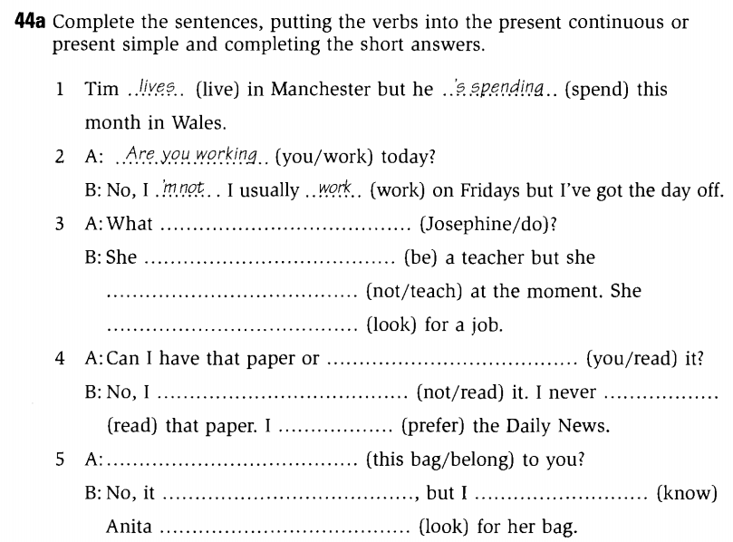

- New lesson.

 | Teacher | Students
20’ | Vocabulary: the goal of this section is to present and practice the target vocabulary of the unit  - Activity 1: Picture labeling  - Focuses Ss’ attention on the pictures and checks to see which ones Ss already know  - Explains the vocabulary items that Ss don’t know and has them do the activity.  - Activity 2: Listen and check (CD1-track 42)  - Plays the recording and checks the answers of activity 1  - Activity 3: Pair work  - Draws Ss’ attention on the pictures and elicits guessing from students to form a story (elicits the key vocabulary depicted in the pictures)  - Has Ss work in pair and do the activity  - Has pairs present their story | - Listen to the T  - Do the activity  - Listen and check the answers  Expected answer  - late  - the weather  - lost  - broken  - the lines  - crowded  - the traffic  - sick  - Listen to the T  - Do the activity  - Present the story to the class
20’ | Conversation: the goal of this section is to present and practice the target vocabulary and grammar of the unit in a typical conversation  - Activity 1: Picture description  - Focuses Ss’ attention on the picture and asks some questions:  Who are the people?  Where are they?  What are they saying?  - Activity 2: Listen and check (CD1-track 43)  - Focuses Ss’ attention on the model conversation  - Pre-teaches the words and phrases  Pardon me!: using context  crowded (adj): using explanation  - Has Ss do the activity  - Plays the recording and checks the answers  - Asks two Ss to model the conversation  - Has Ss practice in pairs  - Activity 3: Pair work  - Shows the examples and has Ss do the activity  - Activity 4: Free practice  - Elicits other examples of job titles and places  - Has Ss practise in pairs | - Listen to the T and answer the questions  - Listen to the T  - Do the activity  - Check the answers  Expected answers  1b – 2a – 3c  - Practise the conversation  - Do the activity  - Respond to the T  - Do the activity
70’ | Language Practice: the goal of this section is to present and practice Simple Past  - Explain the rules  - Provides Ss with some examples  Ex:  Nam was at home yesterday.  We were at school yesterday.  - Elicits the meaning of the examples  - Emphasizes the use of Simple Past  - Elicits the use of was/ were  - Has Ss give examples to check understandings  - Activity 1: Completing conversations  - Gives instructions and an example  - Has Ss do the activity  - Checks the answers  - Activity 2: Completing sentences  - Gives instructions and an example  - Has Ss do the activity  - Checks the answers  - Activity 3: Pair work  - Models the example and give instructions  - Has Ss work in pairs to complete the sentences  - Checks the Ss’ work and gives feedback  - Workbook  - Has Ss do the workbook P. 31-32-33  - Checks the answers | - Respond to the T  Expected answers:  Was: goes with plural subject  Were: goes with singular subject  - Listen to the T and take notes  - Listen to the T  - Do the activity  - Check answers  Expected answers:  - was, wasn’t, was  - was, was  - weren’t, were  - was, was  - Listen to the T  - Do the activity  - Check answers  - Listen to the T  - Do the activity  - Listen to the T  - Do the workbook  - Check the answers
15’ | Pronunciation: the goal of this section to focus on the reduced form of “was, wasn’t, were, weren’t”  - Activity 1: Listen and repeat (CD1- track 45)  - Models the examples and has the Ss repeat  - Plays the recording and has Ss practice saying the examples  - Activity 2: Pair work  - Has Ss work in pairs and do the activity | - Listen to the T and repeat  - Listen and practise saying the examples  - Work in pairs and do the activity
40’ | Listening: The goal of this section is to practise listening selectively for key information  - Picture describing  - Focuses Ss’ attention on the pictures and elicits relating vocabulary:  ticket (n): using explanation  plane (n): using drawing  pocket (n): using realia  suitcase (n): using drawing  busy (adj): using antonym  impossible (adj): using explanation  - Has Ss guess the content of their conversations  Where are they?  Which person is late?  What are they saying?  - Listen and number (CD1-track 47)  - Gives instruction and focuses Ss’ attention on the key words  - Plays the recording and has Ss do the activity  - Checks the answers  - Listen and number (CD1-track 48)  - Gives instruction, focuses Ss’ attention on the options  - Plays the recording and has Ss do the activity  - Checks the answers | - Try to describe the pictures  - Guess the content of the conversations  - Listen to the T  - Do the activity  - Listen to the T & check the answers  Expected answers:  A2 – B1 – C3  - Listen to the T  - Do the activity  - Listen to the T & check the answers  Expected answers:  1b – 2b – 3a
30’ | Smart Talk:  - Review vocabulary (focus on pronunciation)  party (n)  gym (n)  concert (n)  beach (n)  mountain (n)  - Gives instructions and has Ss do the activity in pairs  - Gives feedback | - Listen and respond to the T  - Do the activity  - Listen to the T
40’ | Reading: the goal of this section is to practise reading comprehension  - Activity 1: Pre-reading  - Asks Ss to determine the form of the text  - Focuses Ss’ attention on the title and pictures and lets Ss guess the topic of the article.  - Asks Ss some questions:  How many members are there in the band?  Who are they?  - Elicits related vocabulary  bass player (n): using explanation  singer (n): using example  receptionist (n): using explanation  guitarist (n): using semantic map  drummer (n): using semantic map  prefer + v-ing (v): using example  join (v): using synonym  - Activity 2: Reading comprehension (CD1- track 49)  - Gives instructions  - Lets Ss listen to the recording  - Has Ss do the activity  - Checks answer  - Activity 3: Reading comprehension  - Gives instructions  - Has Ss do the activity  - Checks answer  - Asks Ss some questions:  What did each person do before they joined in the band? | - Respond to the T  Expected answer: an article  - Guess the topic of the article  Expected answer: success of a band  - Respond to the T  Expected answer:  Five  Carrie, Carl, Ellie May, Joe, Billy  - Listen to the T and take note new words.  - Listen to the T  - Listen to the recording  - Do the activity  - Check answers  Expected answers:  - b/e – 2. b/e – 3. a – 4. c – 5. d  - Listen to the T  - Do the activity  - Check answers  Expected answers:  - T – 2. F – 3. T – 4. F  - Respond to the T  Expected answer:  Carrie: in an all-girl band called Daisy Park  Carl: a taxi driver  Ellie May: a hotel receptionist  Joe: drummer in another band  Billy: in another band called Easy Stones
25’ | Enjoying English: The goal of this section is to practice the language in the unit in an enjoyable, meaningful, and personalized way  - Activity 1:  - Focuses Ss’ attention on the pictures and elicits answers from the Ss for the questions:  Where were they?  Who were they with?  - Has Ss fill in the column YOU  - Activity 2:  - Models the example conversation  - Lets Ss work in group, asking and answering about where they were and who they were with  - Activity 3:  - Writes the model sentence on the board  - Has Ss report what they learn about other Ss | - Brainstorm ideas and takes notes  - Do the activity  - Listen to the Ss  - Do the activity  - Do the activity
30’ | Writing: The goal of this section is to practise writing a paragraph about oneself  - Has Ss read the diary and checks their understandings  - Elicits some useful structures  - Has Ss do the activity  - Asks some students write their work on the board and gives feedbacks | - Read the diary  - Listen to the teacher  - Do the activity  - Show the work and correct

VIII. SUMMARY OF UNIT 6: 5 minutes
- T reminds Ss about:
+ Vocabulary
+ Simple Past
+ Useful language of past events

IX. HOMEWORK:
- Ss have to do the workbook and prepare for the new lesson.

X. SELF-ASSESSMENT:
- The teaching methods are good because:
+ There are facilities and materials for students to study better.
+ The teacher’s preparation is careful.
XI. HAND-OUTS:

Ngày tháng năm 201
THÔNG QUA TỔ BỘ MÔN Chữ ký giáo viên

NGUYỄN THỊ MINH QUÝ Trần Thanh Trúc

Subject: English 1  Lesson plan: 8  Date of teaching: 23/12/2015 | Time allowed: 2 periods | Total period taught: 39

Review: Unit 4-6

I. OBJECTIVES
This unit aims to review:
- Vocabulary: Units 4-6
- Grammar: The simple present tense – Present Continuous – Simple Past
- Listening: Listening comprension skill
- Reading: Reading comprension skill

II. METHOD
- Integrated, communicative oriented teaching approach.

III. TECHNIQUES
- Individual work
- Pair work.
- Group work.

IV. TEACHING AIDS
- Textbook.
- Black board, chalk.
- Cassette player, amplifier, microphone.
- Handouts to reviews old lesson

V. PROCEDURE
- Greetings.
- Checking students’ attendance: 5 minutes
- Revision of the old lesson: 10 minutes
Simple Past of Tobe: T lets Ss do the exercise on their own.
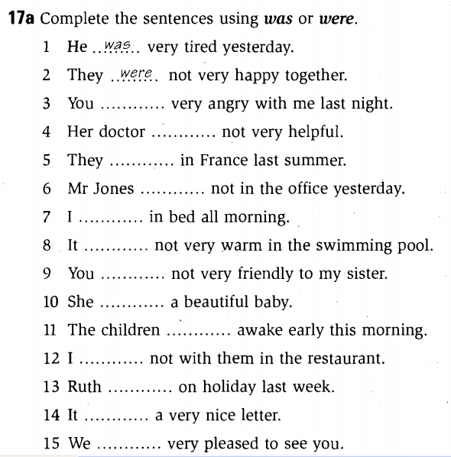

- New lesson.

 | Teacher | Students
10’ | Song: the goal of this section is to review the language presented in Unit 4-6  - Activity 1: Pre-listening  - Focus Ss’ attention on the picture and asks Ss some questions:  Where’s the girl?  Why is she sad?  - Activity 2: While-listening (CD1 – track 50)  - Plays the recording  - Has Ss to circle the correct answer | - Respond to the T  - Listen to the recording  - Do the activity  Expected answers  - on the phone  - all alone  - aren’t  - something’s  - down the street  - and me
20’ | Story: the goal of this section is to review and practice the language presented in Unit 4-6 in a fun way  - Activity 1:  - Focuses Ss’ attention on the comic strip and asks some questions:  Where are people?  Is the boy speaking quietly or loudly?  Why is the boy speaking loudly?  - Activity 2: (CD1 – track 51)  - Focuses Ss’ attention on the blanks and the answers choice  - Model the first one as an example  - Has Ss do the activity  - Plays the recording and checks the answers  - Activity 3: Pair work  - Asks two Ss to model the conversation  - Has Ss practice in pairs  - Activity 4: Free practice  - Shows the examples and has Ss do the activity  - Has Ss perform in front of the class  - Activity 5: Workbook  - Has Ss do the workbook P.35-38 | - Listen to the T and answer the questions  - Respond to the T  - Listen to the T  - Do the activity  - Check the answers  Expected answers  1b– 2a – 3b – 4b  - Practise the conversation  - Do the activity  - Do the activity using their ideas  - Perform in front of the class  - Do the workbook
45’ | One-period Test

VIII. SUMMARY: 5 minutes
- T reminds Ss about main content of the lesson

IX. HOMEWORK:
- Ss have to do the workbook and prepare for the new lesson.

X. SELF-ASSESSMENT:
- The teaching methods are good because:
+ There are facilities and materials for students to study better.
+ The teacher’s preparation is careful.
XI. HAND-OUTS:
Ngày tháng năm 201
THÔNG QUA TỔ BỘ MÔN Chữ ký giáo viên

NGUYỄN THỊ MINH QUÝ Trần Thanh Trúc

Subject: English 1  Lesson plan:9  Date of teaching: 23/12/2015 | Time allowed: 7 periods | Total period taught: 46

UNIT 7: Which one is cheaper?

I. OBJECTIVES
By the end of the lesson, the students will be able to:
- Listen to people shopping
- Describe differences
- Read an article about people who love expensive designer clothes
- Write about the clothes you wear
- Extend vocabulary about clothing
- Learn Comparative adjectives
- Practise Sentence stress

II. METHOD
- Integrated, communicative oriented teaching approach.

III. TECHNIQUES
- Individual work
- Pair work.
- Group work.

IV. TEACHING AIDS
- Textbook.
- Black board, chalk.
- Cassette player, amplifier, microphone.
- Hand-outs to review the old lesson

V. PROCEDURE
- Greetings.
- Checking students’ attendance: 5 minutes
- Revision of the old lesson: 10 minutes
Simple Past of Tobe: T lets Ss do the exercise in pairs
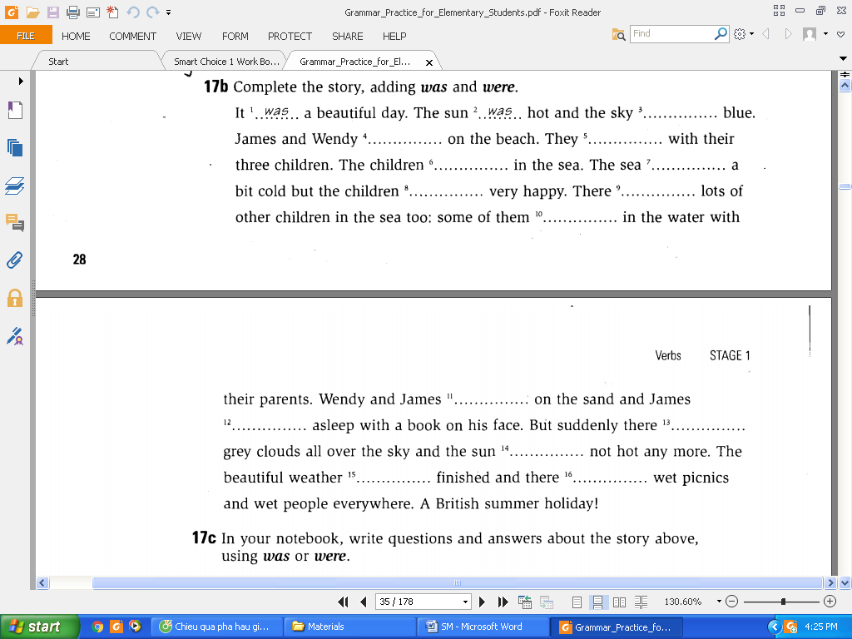
- New lesson.

 | Teacher | Students
20’ | Vocabulary: the goal of this section is to present and practice the target vocabulary of the unit  - Activity 1: Picture labeling  - Focuses Ss’ attention on the pictures and checks to see which ones Ss already know  - Explains the vocabulary items that Ss don’t know and has them do the activity.  - Activity 2: Listen and check (CD2-track 2)  - Plays the recording and checks the answers of activity 1  - Activity 3: Pair work  - Models the conversation and draws Ss’ attention on the items of clothing that are underlined in the conversation  - Has Ss work in pair and do the activity  - Has pairs present their conversation | - Listen to the T  - Do the activity  - Listen and check the answers  Expected answer  1a – 2d – 3f – 4g – 5e – 6i –  7l – 8j – 9b – 10h – 11k – 12c  - Listen to the T  - Do the activity  - Present the conversation to the class
20’ | Conversation: the goal of this section is to present and practice the target vocabulary and grammar of the unit in a typical conversation  - Activity 1: Picture description  - Focuses Ss’ attention on the picture and asks some questions:  Who are the people?  Where are they?  What are they doing?  - Activity 2: Listen and check (CD2-track 3)  - Focuses Ss’ attention on the model conversation  - Pre-teaches the words and phrases  look for (v): using example  a pair of : using example  cheap – expensive (adj): using example  surprised (adj): using explanation  - Has Ss do the activity  - Plays the recording and checks the answers  - Asks two Ss to model the conversation  - Has Ss practice in pairs  - Activity 3: Pair work  - Shows the examples and has Ss do the activity  - Activity 4: Free practice  - Elicits other examples of job titles and places  - Has Ss practise in pairs | - Listen to the T and answer the questions  - Listen to the T  - Do the activity  - Check the answers  Expected answers  1c – 2d – 3b – 4a  - Practise the conversation  - Do the activity  - Respond to the T  - Do the activity
70’ | Language Practice: the goal of this section is to present and practice Comparatives  - Explain the rules  - Provides Ss with some examples  Ex:  Nam is taller than Huy  This phone is more expensive than that phone.  - Elicits the meaning of the examples  - Elicits the form of Comparative  Short Adj-er than  More Long Adj than  - Has Ss give examples to check understandings  - Provides Ss with some examples  Ex:  Huy isn’t as tall as Nam  That phone isn’t as expensive as this phone.  - Elicits the meaning of the examples  - Elicits the form of Comparative  as + Adj + as  - Has Ss give examples to check understandings  - Emphasizes some exceptions  Good/ well – better  Bad/ badly – worse  Happy – happier  - Activity 1: Completing sentences  - Gives instructions and an example  - Has Ss do the activity  - Checks the answers  - Activity 2: Completing sentences  - Gives instructions and an example  - Has Ss do the activity  - Checks the answers  - Activity 3: Pair work  - Models the example and give instructions  - Has Ss work in pairs to express their agreement or disagreement to the statements  - Checks the Ss’ work and gives feedback  - Workbook  - Has Ss do the workbook P. 40-41-42  - Checks the answers | - Listen to the T and take notes  - Respond to the T  - Listen to the T and take notes  - Listen to the T and take notes  - Respond to the T  - Listen to the T and take notes  - Listen to the T  - Do the activity  - Check answers  Expected answers:  - Cheaper than  - More comfortable than  - More colorful than  - Nicer than  - Newer than  - Cooler than  - Listen to the T  - Do the activity  - Check answers  Expected answers:  - Aren’t as cheap as  - Aren’t as comfortable as  - Isn’t as colorful as  - Isn’t as nice as  - Aren’t as new as  - Aren’t as cool as  - Listen to the T  - Do the activity  - Presents the work in front of the class  - Do the workbook  - Check the answers
15’ | Pronunciation: the goal of this section to focus on the sentence stress  - Activity 1: Listen and repeat (CD2- track 5)  - Models the examples and has the Ss repeat  - Plays the recording and has Ss practice saying the examples  - Activity 2: Pair work  - Has Ss work in pairs and do the activity | - Listen to the T and repeat  - Listen and practise saying the examples  - Work in pairs and do the activity
40’ | Listening: The goal of this section is to practise listening selectively for key information  - Activity 1: Picture describing  - Focuses Ss’ attention on the pictures and elicits relating vocabulary:  Designer clothes (n)  Regular clothes (n)  Italy – Italian  China - Chinese  - Has Ss try comparing the items  - Activity 2: Listen and number (CD2-track 6)  - Gives instruction and focuses Ss’ attention on the key words  - Plays the recording and has Ss do the activity  - Checks the answers  - Activity 3: Listen and number (CD2-track 7)  - Gives instruction, focuses Ss’ attention on the options  - Plays the recording and has Ss do the activity  - Checks the answers | - Try to describe the pictures  - Compare the items  - Listen to the T  - Do the activity  - Listen to the T & check the answers  Expected answers:  A3 – B2 – C1 – D4  - Listen to the T  - Do the activity  - Listen to the T & check the answers  Expected answers:  1b – 2b – 3a – 4b
30’ | Smart Talk:  - Review vocabulary (focus on pronunciation)  price (n): using example  size (n): using example  medium (adj): using synonym  long-sleeved >< short – sleeved (adj): using realia  stylish (adj): using semantic map  practical (adj): using translation  elegant (adj): using translation  fashionable (adj): using semantic map  - Gives instructions and has Ss do the activity in pairs  - Gives feedback | - Listen and respond to the T  - Do the activity  - Listen to the T
40’ | Reading: the goal of this section is to practise reading comprehension  - Activity 1: Pre-reading  - Asks Ss to determine the form of the text  - Focuses Ss’ attention on the title and pictures and lets Ss guess the topic of the article.  - Elicits the designer brand names that Ss know and the countries associated with the brands  - Elicits related vocabulary  hairdresser (n): using explanation  wear (v): using mime  believe it or not: using context  giant (adj): using synonym  expert (n): using translation  quality (n): using translation  famous (adj): using example  definitely (adj): using translation  ordinary (adj): using antonym  - Activity 2: Reading comprehension (CD2- track 8)  - Gives instructions  - Lets Ss listen to the recording  - Has Ss do the activity  - Checks answer  - Activity 3: Reading comprehension  - Gives instructions  - Has Ss do the activity  - Checks answers  - Asks Ss some questions:  How much is Kevin’s T-shirt?  How many $200 T-shirts does Kevin have?  Why do people like designer jeans? | - Respond to the T  Expected answer: an article  - Guess the topic of the article  Expected answer: clothes, jeans  - Respond to the T  - Listen to the T and take note new words.  - Listen to the T  - Listen to the recording  - Do the activity  - Check answers  Expected answers:  $40: the cost of a pair of ordinary jeans  $200: the cost of one of Kevin’s T-shirts  $400: the cost of Kevin’s jeans  $535: the cost of a John Galliano T-shirt  $5000: the amount of money Kevin spends each year on clothes  - Listen to the T  - Do the activity  - Check answers  Expected answers:  - b – 2. a – 3. b – 4. a  - Respond to the T  Expected answer:  $200  Five  Designer jeans looks better, are cooler, are better quality. Designer jeans have a famous designer’s name on them
25’ | Enjoying English: The goal of this section is to practice the language in the unit in an enjoyable, meaningful, and personalized way  - Activity 1:  - Focuses Ss’ attention on the pictures and reviews vocabulary of clothing  - Checks Ss’ understanding of the questions  - Has Ss fill in the column YOU  - Activity 2:  - Models the example conversation  - Lets Ss work in group, asking and answering about where they were and who they were with  - Activity 3:  - Writes the model sentence on the board  - Has Ss report what they learn about other Ss | - Brainstorm ideas and takes notes  - Respond to the T  - Do the activity  - Listen to the T  - Do the activity  - Do the activity  - Report in front of the class
30’ | Writing: The goal of this section is to practise writing a paragraph about oneself  - Has Ss read the email and Checks Ss’ understandings  - Elicits Ss’ respond to the questions  - Elicits some useful structures  - Has Ss do the activity  - Asks some students write their work on the board and gives feedbacks | - Read the email  - Brainstorm the ideas  - Listen to the teacher  - Do the activity  - Show the work and correct

VIII. SUMMARY OF UNIT 7: 5 minutes
- T reminds Ss about:
+ Vocabulary about clothing
+ Comparatives
+ Useful language to describe the differences among things

IX. HOMEWORK:
- Ss have to do the workbook and prepare for the new lesson.

X. SELF-ASSESSMENT:
- The teaching methods are good because:
+ There are facilities and materials for students to study better.
+ The teacher’s preparation is careful.
XI. HAND-OUTS:

Ngày tháng năm 201
THÔNG QUA TỔ BỘ MÔN Chữ ký giáo viên

NGUYỄN THỊ MINH QUÝ Trần Thanh Trúc

Subject: English 1  Lesson plan: 10  Date of teaching: 06/01/2016 | Time allowed: 7 periods | Total period taught: 53

UNIT 8: What’s she like?

I. OBJECTIVES
By the end of the lesson, the students will be able to:
- Listen to people describing themselves and others
- Describe people
- Read a magazine-style personality quiz
- Write about your personality, appearance, and hobbies
- Extend vocabulary about appearance and personality
- Learn about the usage of “look like” and “be like”
- Practice Sentence intonation

II. METHOD
- Integrated, communicative oriented teaching approach.

III. TECHNIQUES
- Individual work
- Pair work.
- Group work.

IV. TEACHING AIDS
- Textbook.
- Black board, chalk.
- Pictures for teaching vocabulary.
- Cassette player, amplifier, microphone.
- Hand-outs to review the old lesson

V. PROCEDURE
- Greetings.
- Checking students’ attendance: 5 minutes
- Revision of the old lesson: 10 minutes
Comparatives: T lets Ss do the exercise on their own
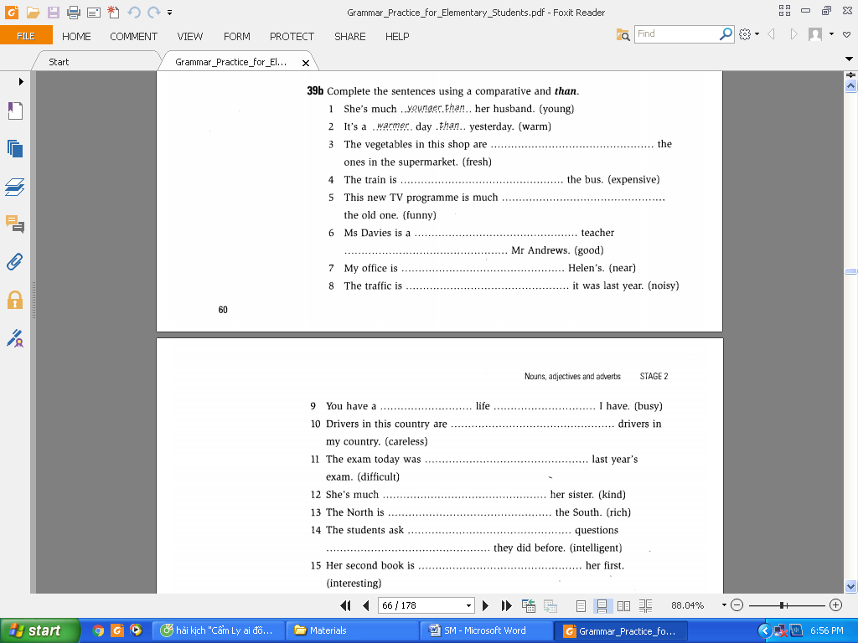

- New lesson.

 | Teacher | Students
20’ | Vocabulary: the goal of this section is to present and practice the target vocabulary of the unit  - Activity 1: Picture labeling  - Focuses Ss’ attention on the pictures and asks them how the people looks/ seems  - Elicits some adjectives Ss already knows puts them into the two column “appearance” “personality”  - Explains the vocabulary items that Ss don’t know and has them do the activity.  - Emphasizes the order of Adjectives  Size – shape – color + N  Ex: long curly black hair  - Activity 2: Listen and check (CD2-track 9)  - Plays the recording and checks the answers of activity 1  - Activity 3: Pair work  - Models the conversation  - Has Ss work in pair and do the activity  - Has pairs present their conversation | - Respond to the T  - Respond to the T  - Do the activity  - Listen to the T  - Listen and check the answers  Expected answer  Tim is short and heavy. He has long, straight blonde hair and blue eyes. He seems nice and friendly  Eva is short. She has short, curly dark hair. She seems quiet and shy  - Listen to the T  - Do the activity  - Present the conversation to the class
20’ | Conversation: the goal of this section is to present and practice the target vocabulary and grammar of the unit in a typical conversation  - Activity 1: Picture description  - Focuses Ss’ attention on the picture and asks Ss to describe the people in the picture  - Activity 2: Listen and check (CD2-track 10)  - Focuses Ss’ attention on the model conversation  - Pre-teaches the words and phrases  hard-working (adj): using antonym  high school (n): using example  I wish …  - Has Ss do the activity  - Plays the recording and checks the answers  - Asks two Ss to model the conversation  - Has Ss practice in pairs  - Activity 3: Pair work  - Shows the examples and has Ss do the activity  - Activity 4: Free practice  - Elicits other examples of job titles and places  - Has Ss practise in pairs | - Listen to the T and answer the questions  - Listen to the T  - Do the activity  - Check the answers  Expected answers  1c – 2d – 3a – 4b  - Practise the conversation  - Do the activity  - Respond to the T  - Do the activity
70’ | Language Practice: the goal of this section is to present and practice the target grammar point  - Explain the rules  - Provides Ss with some examples  Ex:  What’s he like? He is nice and funny  What does he look like? He’s tall and good-looking  Who does he look like? He looks like Tom Cruise  - Elicits the meaning of the examples  - Elicits the usage of “look like” and “be like”  - Has Ss give examples to check understandings  - Activity 1: Matching  - Gives instructions and an example  - Has Ss do the activity  - Checks the answers  - Activity 2: Completing the conversation  - Gives instructions and an example  - Has Ss do the activity  - Checks the answers  - Workbook  - Has Ss do the workbook P.45-46-47  - Checks the answers | - Listen to the T and take notes  - Respond to the T  Expected answers  Look like: used to describe appearance  Be like: used to describe personality  - Respond to the T  - Listen to the T  - Do the activity  - Check answers  Expected answers:  1d – 2b – 3e – 4a – 5c  - Listen to the T  - Do the activity  - Check answers  Expected answers:  - What’s she like?  - What do they look like?  - What are they like?  - Do the workbook  - Check the answers
15’ | Pronunciation: the goal of this section to focus on the sentence intonation  - Activity 1:Listen and repeat (CD2- track 12)  - Models the examples and has the Ss repeat  - Plays the recording and has Ss practice saying the examples  - Activity 2: Pair work  - Has Ss work in pairs and do the activity | - Listen to the T and repeat  - Listen and practise saying the examples  - Work in pairs and do the activity
40’ | Listening: The goal of this section is to practise listening selectively for key information  - Picture describing  - Focuses Ss’ attention on the pictures and asks them to describe the people in the picture (appearance, personality)  - Elicits relating vocabulary  bald (adj): using picture  ad (n): using explanation  roommate (n): using explanation  neat (adj): using antonym  baseball star (n): using example  - Listen and number (CD2-track 13)  - Gives instruction and focuses Ss’ attention on the key words  - Plays the recording and has Ss do the activity  - Checks the answers  - Listen and number (CD2-track 14)  - Gives instruction, focuses Ss’ attention on the options  - Plays the recording and has Ss do the activity  - Checks the answers | - Try to describe the pictures  - Listen to the T  - Listen to the T  - Do the activity  - Listen to the T & check the answers  Expected answers:  1b – 2b – 3a – 4b  - Listen to the T  - Do the activity  - Listen to the T & check the answers  Expected answers:  1c – 2a – 3b – 4b
30’ | Smart Talk:  - Reviews the questions  - Asks Ss to complete the column “Your best friend”  - Gives instructions and has Ss do the activity in pairs to exchange information about their best friends  - Gives feedback | - Listen and respond to the T  - Complete the table  - Do the activity  - Listen to the T
40’ | Reading: the goal of this section is to practise reading comprehension  - Activity 1: Reading comprehension (CD2- track 15)  - Asks Ss to determine the form of the text  - Focuses Ss’ attention on the title and pictures and elicits some adjectives to describe personality  - Teaches some vocabulary  sensible (adj): using translation  individual (adj) using translation  characteristic (n) using synonym  classical (n) using translation  - Checks if Ss understand all the questions  - Gives instructions  - Lets Ss listen to the recording  - Has Ss do the activity  - Activity 2: Group work  - Teaches some vocabulary  sociable (adj): using translation  lively (adj): using translation  independent (adj) : using translation  - Shows Ss how to add up the points to find the score  - Gives instructions  - Work in group to compare the score  - Activity 3: Reading comprehension  - Review some useful phrases such as I think…, I agree…, I disagree…  - Gives instructions  - Has Ss do the activity | - Respond to the T  Expected answer: a quiz  - Guess the topic of the article  Expected answer: clothes, jeans  - Listen to the T and take note new words.  - Respond to the T  - Listen to the T  - Listen to the recording  - Do the activity  - Listen to the T and take note new words.  - Find the score  - Listen to the T  - Work in group  - Listen to the T  - Listen to the T  - Do the activity
25’ | Enjoying English: The goal of this section is to practice the language in the unit in an enjoyable, meaningful, and personalized way  - Activity 1:  - Focuses Ss’ attention on the key word “life partner” and elicits some attributes and writes them on the board  - Has Ss do the activity on their own  - Activity 2:  - Draws the table on the board  - Models the example conversation  - Lets Ss work in group, asking and answering about their life partner | - Brainstorm ideas  - Do the activity  - Listen to the T  - Do the activity
30’ | Writing: The goal of this section is to practise writing a paragraph about oneself  - Has Ss read the email and checks Ss’ understandings  - Elicits Ss’ respond to the questions:  What’s his name?  What does he look like?  What’s he like?  What are his hobbies?  Where he want a pen pal?  - Elicits some useful structures  - Has Ss do the activity  - Asks some students write their work on the board and gives feedbacks | - Read the paragraph  - Answer the questions  - Listen to the teacher  - Do the activity  - Show the work and correct

VIII. SUMMARY OF UNIT 8: 5 minutes
- T reminds Ss about:
+ Vocabulary about appearance and personality
+ “look like” and “be like”
+ Useful language to describe people

IX. HOMEWORK:
- Ss have to do the workbook.

X. SELF-ASSESSMENT:
- The teaching methods are good because:
+ There are facilities and materials for students to study better.
+ The teacher’s preparation is careful.
XI. HAND-OUTS:

Ngày tháng năm 201
THÔNG QUA TỔ BỘ MÔN Chữ ký giáo viên

NGUYỄN THỊ MINH QUÝ Trần Thanh Trúc

